Whitewater Rafting Site Plan

Purpose

To provide an exciting outdoor activity for adventure seekers, attracting both local and international tourist. Additionaly we are here to promote fitness, teamwork, and stress relief, making it a great place of activity for individuals and group.

Goals

1.Promote Adventure Tourism – Provide an exhilarating and safe experience that attracts both local and international tourists.

2.Economic Growth & Job Creation – Generate revenue for the local economy by creating jobs in tourism, hospitality, and guiding services.

3.Encourage Environmental Conservation – Promote sustainable tourism by protecting river ecosystems and educating visitors on conservation.

4.Enhance Physical & Mental Well-being – Offer a recreational activity that promotes fitness, teamwork, stress relief, and mental resilience.

5.Support Community Development – Engage local communities through employment, training programs, and partnerships with local businesses.

Target Audience

Demographics: Offer guided tours that showcase natural beauty and local attractions.

Psychographics: Provide relaxation and stress relief through nature-based adventure tourism.

User Personas: Focus on teamwork, communication, and problem-solving.

Scenarios

The website should answer the following scenario questions:

• Information on trip levels and difficulty

• Detailed descriptions of what to expect during the trip

• Testimonials and reviews from previous customers

• Information on family-friendly trips and age restrictions

• Details on safety measures and equipment provided

• Options for booking a private guide or group trip

• Recommendations for nearby activities and attractions for non-rafters

• High-quality photos and videos showcasing the trip

• Options for customizing the trip (e.g., private guides, camping)

SiteMap

Branding

Logo

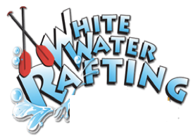

Style Guild

Color Schema

<https://coolors.co/a0ddff-8bb6e6-c1cefe-7189ff-624cab>

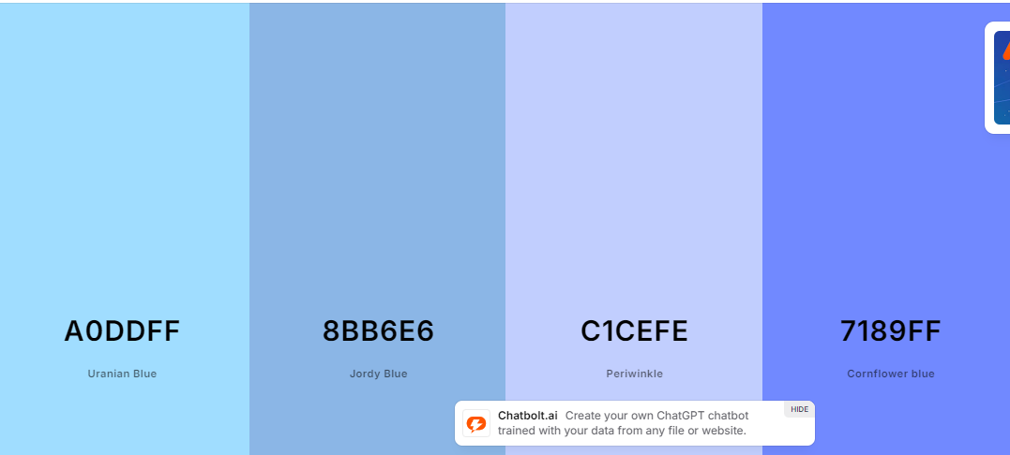

Primary: a0ddff

Secondary: 8BB6E6

Accent1: 7189FF

Accent2: C1CEFE

Typography

Headings-font: Open Sans 300 - 900

Text-font: Roboto 100, 400 and 900